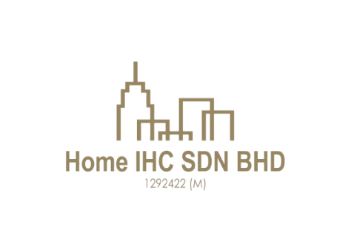
HOME IHC SDN.BHD [201801030396 (1292422-M)]
F-75 Tingkat Atas Jalan Tengku Ismail, 28000 Temerloh Pahang.
(O) 011-630 44931 / 011-100 44931
Email: homeihc22@gmail.com

CUSTOMER PROPERTY VIEWING ACKNOWLEDGEMENT No:

PARTICULARS OF CUSTOMER(S) Date:
Full Name:  No of pax:  Company Name:  Company Address:  Car plate no:  Tel (Hp):  Called in date:  Refer to: | Customer’s request:  Requirement:  Types of Properties:  Property Link:  Location:  Remarks:  Assigned to:
   | MR |  | MRS |  | MS
  iProperty
  Mudah
  Bentongland Website
  Banner
  Whatsapp
  Facebook
   | Agricultural Land
   | Commercial Land |  | Hotel / Resort
   | Industrial Land |  | Factory
   | Residential Land |  | Condominium
  Co-Broke Partner
  Direct Seller

I/We acknowledge and confirm that I/We have visited and inspected the abovementioned property/properties through the efforts and services provided by Home IHC Sdn. Bhd. (Company No: 1292422-M) and Era Realtor Sdn. Bhd. [E(1)2053/1]. Furthermore, should I/We, my nominee, or a nominated company express interest in purchasing the abovementioned property/properties during the site viewing, it shall still be deemed a sale facilitated by Home IHC Sdn. Bhd. and Era Realtor Sdn. Bhd. [E(1)2053/1]. Should I/We, my nominee, or a nominated company in which I/We have an interest or connection, be interested in purchasing any of the abovementioned property/properties, I/We hereby agree not to negotiate directly with the landlord.

_______________________________ _______________________________
Customer Attended staff/representative
Name: Name:
Date: Date:

Property Proposed/ Viewed Date:

No | Property’s Details | Viewing date | Selling Price | Description
1.
2.

If additions, the submission of documents (eg: title, plans) to the prospective customer,

No | Documents | Qty | Signature | Remarks
1. | - Title | 1 set
  GM
  GRN
  HSM
  HSD
  Pajakan Mukim
  Pajakan Negeri
  Topo Plan
  Whatsapp Messenger
  Handover by hardcopy

27.03.2025

